ECE 560 B6 Lab 6 Report

Silicon Photonics Systems

Sumant Sakhalkar

CSU ID: 831685037

**Objective:**

The objective of this lab is to design MRRs of radius 10.005um and 9.995um in KLayout using SiEPIC PDK tool

**Summary of Approach:**

The video and the lecture slides of week 8 were of tremendous help as they gave a step-by-step method of fabricating an MRR on a silicon chip. The links provided by the professor in the earlier labs were also very helpful as they gave me a thorough understanding of the tool.

The design was to be done keeping in mind certain rules. These rules were clearly specified by the professor and were available on the Lumerical website as well. I have followed every instruction provided and the website and have successfully implemented the design.

**Design**

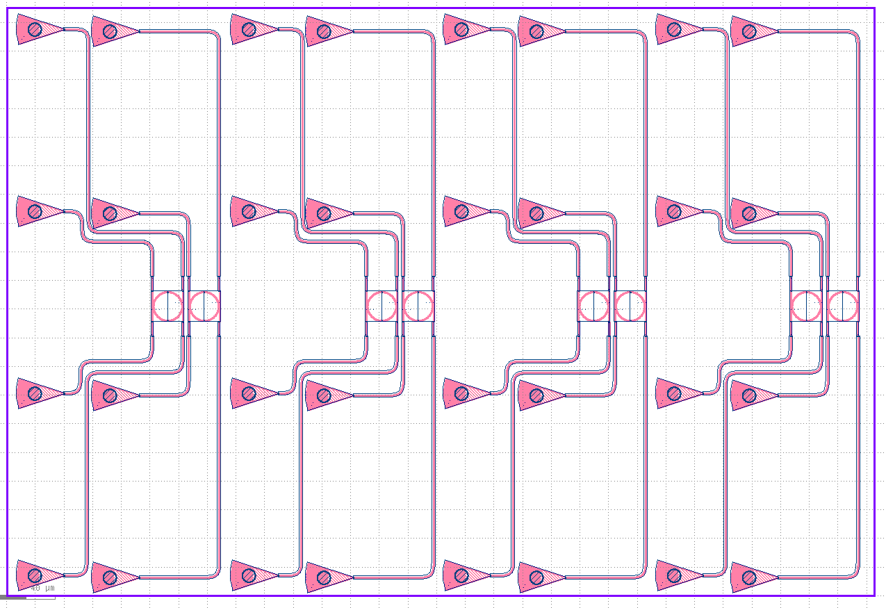

**LABELS:**

The rings are labelled orderly from left to right in ascending order

Opt_in_TE_1550_SumantSakhalkar_Ring1

Opt_in_TE_1550_SumantSakhalkar_Ring2

Opt_in_TE_1550_SumantSakhalkar_Ring3

Opt_in_TE_1550_SumantSakhalkar_Ring4

Opt_in_TE_1550_SumantSakhalkar_Ring5

Opt_in_TE_1550_SumantSakhalkar_Ring6

Opt_in_TE_1550_SumantSakhalkar_Ring7

Opt_in_TE_1550_SumantSakhalkar_Ring8

**CONCLUSION:**

The objective of this lab was to design MRRs and was successfully implemented in KLayout using SiEPIC PDK tool. As seen in the design above the space was optimized efficiently and I managed to fit in 8 MRRs with the specified floorplan.